CURRENT AND FUTURE TRENDS IN THE DISTRIBUTION OF SORGHUM (*Sorghum bicolor* MOENCH)

Lorenzo Seneci

S2240165

Introduction

The genus *Sorghum* is one of the most widespread and evolutionarily successful grass taxa, with 25 species occurring throughout the planet from Australia to North America (Dillon et al. 2007, Paterson et al. 2009). Particularly prominent is the species *Sorghum bicolor*, originally native to East Africa, but domesticated and cultured as a crop since the beginning of agriculture for human as well as livestock consumption (De Wet 1978, Dillon et al. 2007, Paterson et al. 2009). Indeed, occurrence records for this species downloaded from GBIF include data from East Asia, North America, and Europe, where *S. bicolor* was undoubtedly introduced by humans as a crop (De Wet 1978).

Sorghum is a member of the family Poaceae, a highly diverse clade characterized by the photosynthetic mechanism known as C4 (Osborne & Beerling 2006, Christin et al. 2008). C4 plants have a significant advantage over C3 plants in warm, dry ecosystems. In fact, C4 allows better water retention due to the stomata remaining close throughout most of the pathway (Zhang et al. 2003, Christin et al. 2008). Furthermore, C4 photosynthesis is also better suited to cope with low CO2 conditions thanks to its more efficient fixation strategy, whereas C3 plants generally require high CO2 concentrations to outweigh the higher affinity of Rubisco for O2 (Zhang et al. 2003, Osborne & Beerling 2006, Christin et al. 2008). With such premises, it would be logical to expect that sorghum be more common in (sub)tropical regions dominated by dry grassland ecosystems with a monsoon-based precipitation pattern, as its origin in the savanna of East Africa already suggests (De Wet 1978, Osborne & Beerling 2006). However, the current global warming trend might push sorghum to spread to previously unsuitable habitats due to higher temperatures in line with the typical requirements of this species; on the other hand, this would be likely counterbalanced by the increase in atmospheric CO2 via greenhouse gas emissions, which might erase the advantage of C4 plants against their C3 counterparts and therefore increase competition (Osborne & Beerling 2006, Christin et al. 2008). The aim of the present report is to identify the main factors influencing the current distribution of sorghum and provide a reliable estimate of its change in the near future.

Methods

Occurrence records for *S. bicolor* were downloaded from GBIF (DOI: <https://doi.org/10.15468/dl.xap44m> ) and stored in a .csv file with species, latitude, and longitude as relevant parameters. At the same time, climatic measurements for the current year and the year 2050 according to the RPC4.5 scenario were downloaded with a 5 min resolution from WorldClim ([www.worldclim.org](http://www.worldclim.org) ). Both files were then imported in RStudio version 3.5.1 where 19 provided environmental variables were tested for correlation. After discarding highly correlated variables, the following factors were conserved for modelling: bio8 (mean temperature of wettest quarter), bio9 (mean temperature of driest quarter), bio15 (precipitation seasonality), bio16 (precipitation of wettest quarter), bio19 (precipitation of coldest quarter). Aside from their lack of correlation, these variables matched the factors identified as main drivers of suitability of a habitat for *S. bicolor* in previous studies. In fact, sorghum is native to dry, subtropical habitats with high seasonal variations in precipitation, a roughly even light: dark cycle, and stable temperatures throughout the year. The .csv occurrence and climate data was then loaded in MaxEnt version 3.4.1, where they were ultimately run to produce a species distribution model (SDM). Finally, the resulting data were clipped to construct species distribution maps highlighting the loss and gain of suitable habitat for *S. bicolor* in 2050 compared to today. Qualitative assessment of the model was based on the Area Under the Curve (AUC) value, with the threshold for good quality set at AUC>0.8. The model also used a logistic threshold for maximum specificity plus sensitivity of 0.387.

Results

The results obtained from modelling in MaxEnt were significant (AUC = 0.837, Figure 1). Among the variables, most of the contribution to the model (66.2%, 63.2% with permutation) is ascribed to bio19, followed by bio2 (14.6%, 12.5% with permutation). Together, these two variables thus account for 80.8% of the contribution, 75.7% with permutation (Table 1).

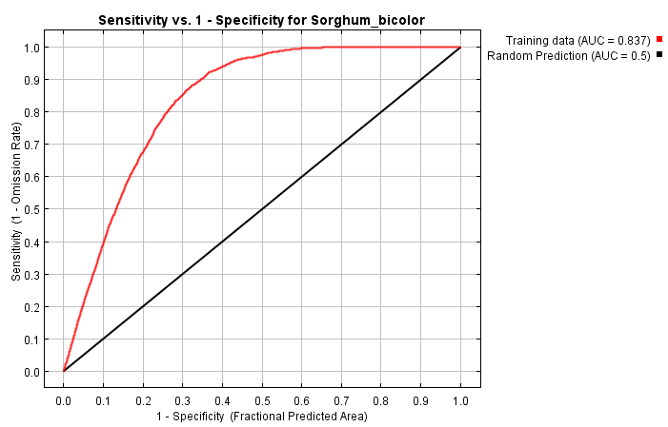

Figure 1. Graph showing the Area Under the Curve (AUC) for the model used in the present report.

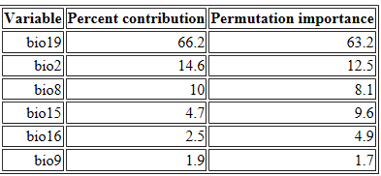Table 1. Percent contribution to the model listed for each variable. Permutation values only differ significantly from default values for bio15, the importance of which nearly doubles in the former compared to the latter.

Predicted habitat suitability for sorghum was estimated by MaxEnt and represented on a map (Figure 2). As indicated by warmer colors, the areas where environmental conditions are more likely to favor sorghum are (sub)tropical Africa, the Indian subcontinent, Southeastern Brazil, and the region around the Gulf of Mexico. The present-day distribution of sorghum only partially mirrors such predictions, as shown in Figure 3A. It is clear that this species is widespread in Africa and India, but only sporadic records are known from the Americas and Europe- the latter continent does not even appear to be suitable for sorghum according to Figure 2. Figure 3B presents the estimated range of sorghum in 2050 under scenario RCP4.5. Based on this prediction, the species will still be widespread in African grasslands and the Indian subcontinent, with a further expansion of its potentially suitable range in North and South America. However, most of the suitable European range will disappear. This is further highlighted in Figure 3C, where the current and future habitat suitability patterns of sorghum are superimposed with different colors indicating loss and gain of range.

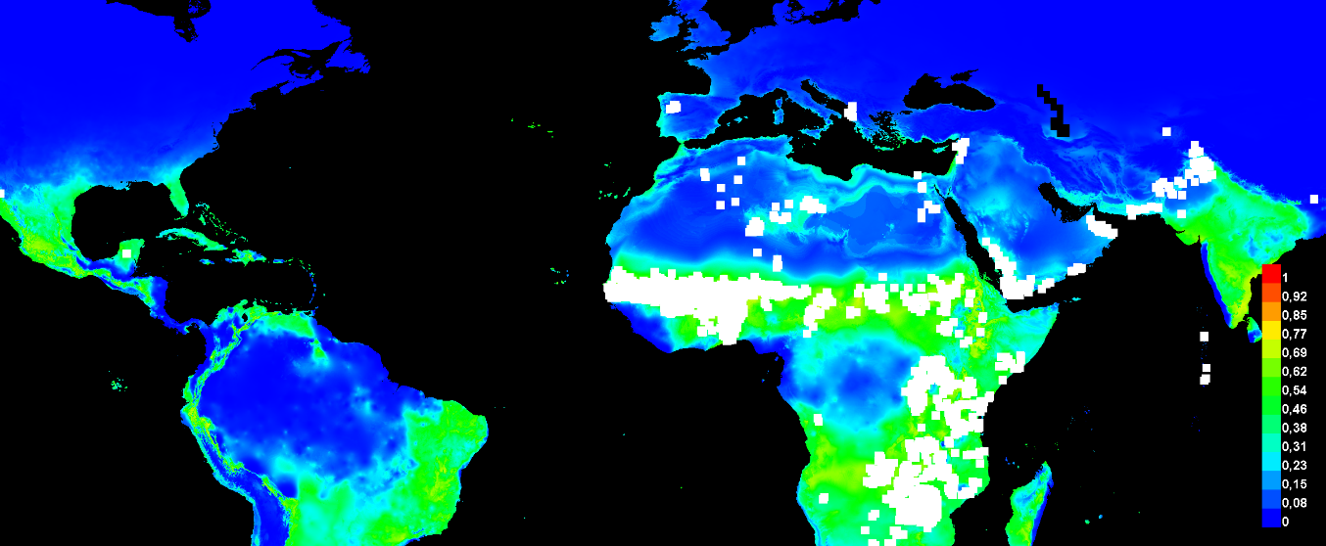

Figure 2. Map depicting habitat suitability estimates for *S. bicolor* throughout its range. Warmer colors indicate better predicted conditions, while the white dots represent occurrence records for the species.

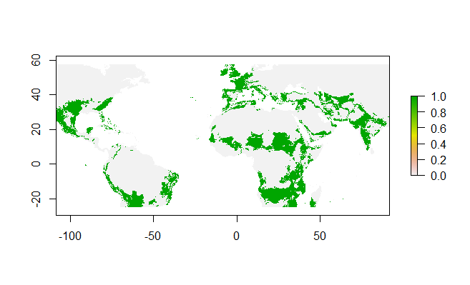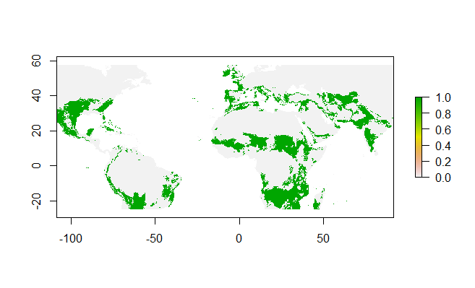

Figure 3B. Map showing the estimated distribution of *S. bicolor* in 2050 according to habitat suitability.

Figure 3A. Map showing the current distribution of *S. bicolor* in green according to habitat suitability.

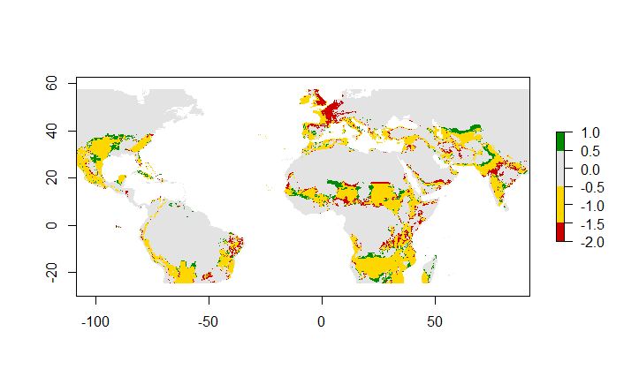

Figure 3C. Habitat suitability map for *S. bicolor* showing both the current and future range (year 2050, RPC4.5). Net loss of territory is shown in red, whereas green indicates net gain and yellow represents unchanged suitability. Gains are small and scattered throughout Africa, North America, and Central Asia, whereas the greatest loss of suitable habitat is clearly visible in Western Europe.

Discussion

*Current distribution and habitat suitability*

The present report provides a species distribution model for the crop plant *Sorghum bicolor* based on relevant environmental parameters and future climate predictions. Current distribution and habitat suitability maps obtained in this study corroborate the findings of previous research, as *S. bicolor* is most likely to occur and most widespread in the dry grasslands and savannas of Sub-Saharan Africa, Central Asia, and the Indian subcontinent. This trend reflects the physiology of this species, which prefers warm regions with highly seasonal precipitation patterns to maximize its competitive advantage over C3 flora (Osborne & Beerling 2006, Paterson et al. 2009). Furthermore, the most important variable in the present model is indeed the amount of precipitation in the coldest quarter of the year, followed by the mean diurnal temperature range. On the other hand, while suitable conditions for sorghum are found in certain regions of North and South America, little to no records of the species from these areas are known. This suggests that important variables influencing habitat suitability for sorghum were not included in the model, resulting in a clear mismatch between estimates and the actual distribution of the species. On the same note, the fact that one single variable accounts for over 60% of the prediction with none of the other variables anywhere near such level of importance, indicates that relevant variables were likely discarded from the model erroneously due to correlation. This bias might also be the reason why the obtained maps indicate that sorghum is found in Western Europe, a region where suitability estimates do not favor this species; therefore, in spite of a high AUC value that indicates good quality, the overall reliability of the model is questionable.

*Future scenario and impact of climate change on species distribution in 2050*

According to the present model, the distribution of *S. bicolor* is unlikely to change considerably, except for significant variations on a local scale. This suggests that climate change will not be a relevant driver of *S. bicolor* distribution in the next three decades under the RPC4.5 scenario. In fact, the main hotspots for this species (i.e. Sub-Saharan Africa and Western India) are expected to lose very little of their sorghum-populated territory, with several net gains also projected. The same pattern is seen in the Americas, with *S. bicolor* even expanding its current range in the United States and Mexico. The only major exception to this trend is Western Europe, where sorghum is likely to disappear almost entirely according to the model. This is surprising, as the global warming trend of Earth’s climate in the near future would result in an increase in average temperature, thereby potentially facilitating the establishment of sorghum in currently unsuited areas (De Wet 1978, Christin et al. 2008). This apparent discrepancy might be due to the simultaneous human-induced increase in atmospheric CO2 concentrations, which would level the advantage of sorghum over C3 plants in photosynthesis efficiency (Zhang et al. 2003, Osborne & Beerling 2006). However, CO2 levels were not included in the model as a variable- a potentially significant shortcoming of the estimates obtained that negatively affects reliability of the model as a whole.

References

Christin, P. A., Besnard, G., Samaritani, E., Duvall, M. R., Hodkinson, T. R., Savolainen, V., & Salamin, N. (2008). Oligocene CO2 decline promoted C4 photosynthesis in grasses. *Current Biology*, *18*(1), 37-43.

De Wet, J. M. J. (1978). SPECIAL PAPER: SYSTEMATICS AND EVOLUTION OF SORGHUM SECT. SORGHUM (GRAMINEAE). *American journal of botany*, *65*(4), 477-484.

Dillon, S. L., Shapter, F. M., Henry, R. J., Cordeiro, G., Izquierdo, L., & Lee, L. S. (2007). Domestication to crop improvement: genetic resources for Sorghum and S accharum (Andropogoneae). *Annals of botany*, *100*(5), 975-989.

Osborne, C. P., & Beerling, D. J. (2005). Nature's green revolution: the remarkable evolutionary rise of C4 plants. *Philosophical Transactions of the Royal Society B: Biological Sciences*, *361*(1465), 173-194.

Paterson, A. H., Bowers, J. E., Bruggmann, R., Dubchak, I., Grimwood, J., Gundlach, H., ... & Schmutz, J. (2009). The Sorghum bicolor genome and the diversification of grasses. *Nature*, *457*(7229), 551.

Zhang, Z., Zhao, M., Lu, H., & Faiia, A. M. (2003). Lower temperature as the main cause of C4 plant declines during the glacial periods on the Chinese Loess Plateau. *Earth and Planetary Science Letters*, *214*(3-4), 467-481.